 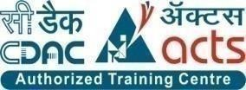

**INSTITUTE FOR ADVANCED COMPUTING ANDSOFTWARE DEVELOPMENT (IACSD), AKURDI, PUNE**

Documentation On

Budget Buddy

PG-DAC March 2023

# Submitted By:

**Group No: 72**

**Roll No. Name:**

**233151 Vaylon Fernandes**

**233228 Vaibhav Jogad**

**Mrs. Manjiri Deshpande Mr. Rohit Puranik**

**Project Guide Centre Coordinator**

# ABSTRACT

Budget Buddy Web App is a web-based application that helps users track their income, expenses, and financial goals. The app will provide users with a variety of features, including:

* User registration and authentication: Users can create an account and log in to the app.
* Income management: Users can add income transactions, such as paychecks, freelance earnings, and investment income.
* Expense management: Users can add expense transactions, such as rent, groceries, and transportation costs.
* Budget creation and management: Users can create budgets and track their spending against those budgets.
* Financial goal setting: Users can set financial goals, such as saving for a down payment on a house or retirement.
* Report generation: Users can generate reports to track their spending habits and progress towards their financial goals.
* Alerts and reminders: Users can set up alerts and reminders to stay on top of their finances.

The app has the potential to help users improve their financial health by providing them with a convenient and easy-to-use tool to manage their finances.

# ACKNOWLEDGEMENT

I take this occasion to thank God, almighty for blessing us with his grace and taking our endeavor to a successful culmination. I extend my sincere and heartfelt thanks to our esteemed guide, **Mrs. Manjiri Deshpande** for providing me with the right guidance and advice at the crucial juncture sand for showing me the right way. I extend my sincere thanks to our respected **Centre Co-Ordinator Mr.Rohit Puranik**, for allowing us to use the facilities available. I would like to thank the other faculty members also, at this occasion. Last but not the least, I would like to thank my friends and family for the support and encouragement they have given me during the course of our work.

#### Vaylon Fernandes. (223151)

**Vaibhav Jogad (223228)**

Table of Contents

Submitted By: 1

ABSTRACT 2

ACKNOWLEDGEMENT 3

INTRODUCTION 6

1.1 PROJECT OBJECTIVE 7

1.2 PROJECT OVERVIEW 7

1.3 PROJECT SCOPE 8

1.4 STUDY OF THE SYSTEM 8

1.4.1 MODULES: 8

Figure 1 User Activity Diagrams 9

SYSTEM ANALYSIS 11

2.1 EXISTING SYSTEM 11

2.2 PROPOSED SYSTEM 11

2.3 SYSTEM REQUIREMENT SPECIFICATION 12

SYSTEM DESIGN 14

3.1 INPUT AND OUTPUT DESIGN 14

DATABASE DESIGN 16

3.3 SYSTEM TOOLS 16

0 Level DFD 17

E-R Diagram: 19

Class Diagram 20

TABLE STRUCTURE: 21

PROJECT DIAGRAMS 23

CONCLUSION 27

REFERENCES 28

ONLINE REFERENCE 28

**LIST OF FIGURES**

**FIGURE 1: USER ACTIVITY DIAGRAM 9**

**FIGURE 2: 0 LEVEL DFD 17**

**FIGURE 3: 1 LEVEL DFD FOR USER 18**

**FIGURE 4: E-R DIAGRAM 19**

**FIGURE 9: CLASS DIAGRAM 20**

**FIGURE 10: TABLE STRUCTURE 21**

**FIGURE 11: PROJECT DIAGRAMS 23**

# INTRODUCTION

This project is a web application which helps users to manage their personal finances.

An online application to manage personal finances where users can Add, Update their budget and add, update and delete their category wise expenses according to the budget. The users will also be to add and update their savings from various sources. The user can add multiple financial goals by allocating amount from savings.

**Features:** -

1. It can help you track your income and expenses. This can help you see where your money is going and identify areas where you can save money.
2. It can help you track your income and expenses. This can help you see where your money is going and identify areas where you can save money..
3. It can help you set and track financial goals. This can help you stay motivated and on track to reach your financial dreams.
4. It can provide you with reports: this can help you see how your finaces are doing

over time and identify areas to improve.

## PROJECT OBJECTIVE

The purpose of the Budget Buddy web app is to provide users with a user-friendly platform to create budgets, monitor spending, set financial goals, and achieve better control over their personal finances.

## PROJECT OVERVIEW

The application designed into two modules first one is the user who has access to manage his/her personal finances. Second is the admin who can manage view and manage users when required.

The user will be able to enter a budget and enter their expenses. The system keeps a track of the remaining budget which is visible to the user. The user will be notified when the remaining budget is 30% of the set budget. The expenses data is used to generate reports. The user will be able to generate month-wise, custom data range and category-wise expenditure reports. The data from the reports is used to create graphs to help the user get a better visualization of the data. The user will also be able to set financial goals and see a progress bar tracking the progress of the savings done to achieve the goal.

The admin will be able to view a list of all user and manage the accounts. The admin can help users recover their account and delete account on special request. The admin can also provide authorization to delete inactive accounts.

## PROJECT SCOPE

This system provides friendly user interface to users to manage their personal finances. The

Application will help even beginner users with a low amount of money to be able to keep

a track of their spending for e.g. students. Web-platform means that the system will be available for access 24/7 except when there is a temporary server issue which is expected to be minimal.

## STUDY OF THE SYSTEM

## MODULES:

The system after careful analysis has been identified to be presented with the following modules and roles.

The modules involved are:

* + - * User
      * Admin

1.4.1.1 User:

The User has access to the user dashboard to manage his/her expense. Only the has access to their personal finance management page.

This module is divided into different sub modules.

1. Edit Budget
2. Manage Expenses – Create, read, update, delete Expenes (CRUD)
3. Manage Savings (CRUD)
4. View and Generate Reports
5. View Charts

USER:

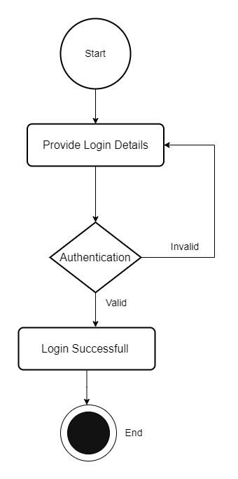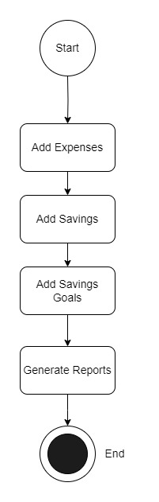

### Figure 1 User Activity Diagrams

#### Add Expenses

User can add expenses once logged in.

#### Add Savings

User can add savings.

#### Add Saving Goals

User can add savings goal

#### Generate Reports

The application can generate predefined reports for the user. The user can also create custom reports.

#### Delete Expenses

User Can delete expenses

#### Delete Savings

User can delete savings

# SYSTEM ANALYSIS

System analysis is the process of gathering and interpreting facts, diagnosing problems, and using the information to recommend improvements on the system. System analysis is a problem-solving activity that requires intensive communication between the system users and system developers.

System analysis or study is an important phase of any system development process. The system is viewed as a whole, the inputs are identified, and the system is subjected to close study to identify the problem areas. The solutions are given as a proposal. The proposal is reviewed on user request and suitable changes are made. This loop ends as soon as the user is satisfied with the proposal.

## EXISTING SYSTEM

The existing system for personal finance management often involves manual methods,

Spreadsheets and standalone software. It suffers from several limitations:

* **Dispersed Information:** Financial data is scattered across various physical documents or digital

files.

* **Manual Data Entry:** Users manually input transactions, which is time-consuming and

prone to errors.

* **Limited Insights:** Lack of data visualization and analysis tools hinders understanding

of spending patterns and financial health.

* **Isolation:** Financial management remains isolated from real-time banking and transaction

data.

* **Inefficient Goal Tracking:** Users struggle to monitor progress towards financial goals

effectively.

## PROPOSED SYSTEM

The proposed system provides friendly user interface to the user and provides a edge over traditional methods by offering an intuitive dashboard for users to input income and expenses, set and monitor financial goals, and visualize spending trends which can be accessed from anywhere in the world. Budget tracking with categorization, alerts, comprehensive data analysis through graphs and reports, and goal progress notifications empower users to make informed financial decisions. With a strong emphasis on security and data privacy, the system aims to provide an all-round and accessible solution that enhances financial awareness and management. Web-platform means that the system will be available for access 24/7 except when there is a temporary server issue which is expected to be minimal.

## SYSTEM REQUIREMENT SPECIFICATION

#### GENERAL DESCRIPTION

**Product Description:**

Budget Buddy allows Society Management System allows members to login with their own account and create budgets, monitor spending, set financial goals, and achieve better control over their personal finances.

#### Problem Statement:

The traditional methods of personal finance, budget management and goal tracking are tedious and time consuming and in many cases maintained using pen and paper methods and hence makes it prone to errors and makes the method prone to errors and hard to keep a track of previous records and track goals. There is a need of a online system that provides a simple and intuitive method to make the process of budget tracking and goal setting simple and error free.

#### SYSTEM OBJECTIVES

* provide users with a user-friendly platform to create budgets, monitor spending, set financial

goals, and achieve better control over their personal finances..

#### SYSTEM REQUIREMENTS

* + - 1. **NON-FUNCTIONAL REQUIREMENTS**

#### EFFICIENCY REQUIREMENT

The user should be able to efficiently access and enter details into the application.

#### RELIABILITY REQUIREMENT

The system should provide a reliable environment to user and admin. All data should be stored on cloud.

#### USABILITY REQUIREMENT

The Web application is designed for user friendly environment and ease of use.

#### IMPLEMENTATION REQUIREMENT

Implementation of the system using React in front end with ASP.NET core as middleware and it will be used for database connectivity. And the database part is developed by MySQL. Responsive web designing is used for making the website compatible for any type of screen.

#### DELIVERY REQUIREMENT

The whole system is expected to be delivered in 1 months of time with timely Evaluation by the project guide.

* + - 1. **FUNCTIONAL REQUIREMENTS**

#### Functional Requirement

* Login Portal for user and admin.
* User has all control over the functionality like add, remove, view, update budget, expenses and savings
* User should be able to generate category-wise, moth-wise and custom date range reports
* User should be able to view charts based on reports.
* Users will receive notifications for approaching bill due dates and exceeding budget limits
* Each user can view only his profile.
* Admin will be able to manage user accounts.

# SYSTEM DESIGN

System design is the solution for the creation of a new system. This phase focuses on the detailed implementation of the feasible system. Its emphasis on translating design. Specifications to performance specification. System design has two phases of development.

Logical Design

Physical Design

During logical design phase the analyst describes inputs (sources), outputs(destinations), databases (data sores) and procedures (data flows) all in a format that meets the user requirements. The analyst also specifies the needs of the user at a level that virtually determines the information flow in and out of the system and the data resources. Here the logical design is done through data flow diagrams and database design. The physical design is followed by physical design or coding. Physical design produces the working system by defining the design specifications, which specify exactly what the candidate system must do. The programmers write the necessary programs that accept input from the user, perform necessary processing on accepted data and produce the required report on a hard copy or display it on the screen.

## INPUT AND OUTPUT DESIGN

#### INPUT DESIGN:

Input design is the link that ties the information system into the world of its users. The input design involves determining the inputs, validating the data, minimizing the data entry and provides a multi-user facility. Inaccurate inputs are the most common cause of errors in data processing. Errors entered by the data entry operators can be controlled by input design. The user-originated inputs are converted to a computer-based format in the input design. Input data are collected and organized into groups of similar data. Once identified, the appropriate input media are selected for processing. All the input data are validated and if any data violates any conditions, the user is warned by a message. If the data satisfies all the conditions, it is transferred to the appropriate tables in the database. In this project the student details are to be entered at the time of registration. A page is designed for this purpose which is user friendly and easy to use. The design is done such that users get appropriate messages when exceptions occur.

#### OUTPUT DESIGN:

Computer output is the most important and direct source of information to the user. Output design

is a very important phase since the output needs to be in an efficient manner. Efficient and intelligible output design improves the system relationship with the user and helps in decision making. Allowing the user to view the sample screen is important because the user is the ultimate judge of the quality of output. The output module of this system is the selected notifications.

# DATABASE DESIGN

* 1. **DATABASE**

Databases are the storehouses of data used in the software systems. The data is stored in tables inside the database. Several tables are created for the manipulation of the data for the system. Two essential settings for a database are

* Primary key - the field that is unique for all the record occurrences
* Foreign key - the field used to set relation between tables Normalization is a technique to avoid redundancy in the tables.

## SYSTEM TOOLS

The various system tools that have been used in developing both the front end and the back end of the project are being discussed in this chapter.

#### FRONT END:

React is a library which is developed by Facebook are utilized to implement the frontend. React (also known as React.js or ReactJS) is a [free and open-source](https://en.wikipedia.org/wiki/Free_and_open-source_software) [front-end](https://en.wikipedia.org/wiki/Free_and_open-source_software) [JavaScript](https://en.wikipedia.org/wiki/JavaScript_library) [library](https://en.wikipedia.org/wiki/JavaScript_library) for building [user interfaces](https://en.wikipedia.org/wiki/User_interfaces) or UI components. It is maintained by [Facebook](https://en.wikipedia.org/wiki/Facebook%2C_Inc) and a community of individual developers and companies. React can be used as a base in the development of [single](https://en.wikipedia.org/wiki/Single-page_application) [page](https://en.wikipedia.org/wiki/Single-page_application) or mobile applications. However, React is only concerned with state management and rendering that state to the [DOM,](https://en.wikipedia.org/wiki/Document_Object_Model) so creating React applications usually requires the use of additional libraries for routing, as well as certain client-side functionality.

#### BACKEND:

The back end is implemented using MySQL which is used to design databases.

#### MySQL:

MySQL is the world's second most widely used open-source relational database management system (RDBMS). The SQL phrase stands for Structured Query Language.

#### ASP.NET Core:

ASP.NET Core is a cross-platform, high-performance, open-source framework for building modern, cloud-enabled, Internet-connected apps.

With ASP.NET Core, you can:

* Build web apps and services, Internet of Things (IoT) apps, and mobile backends.
* Use your favorite development tools on Windows, macOS, and Linux.
* Deploy to the cloud or on-premises.
* Run on .NET Core.

# 0 Level DFD

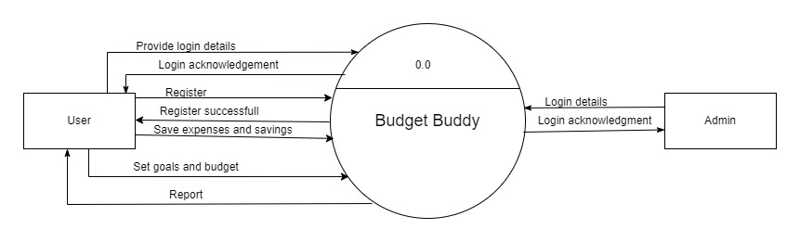

***Figure 2 0 Level DFD***

**1 Level DFD for User**

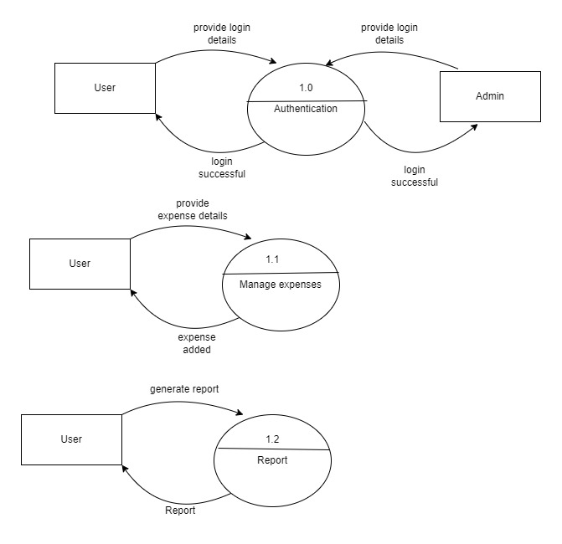

***Figure 3 1 Level DFD for User***

# E-R Diagram:

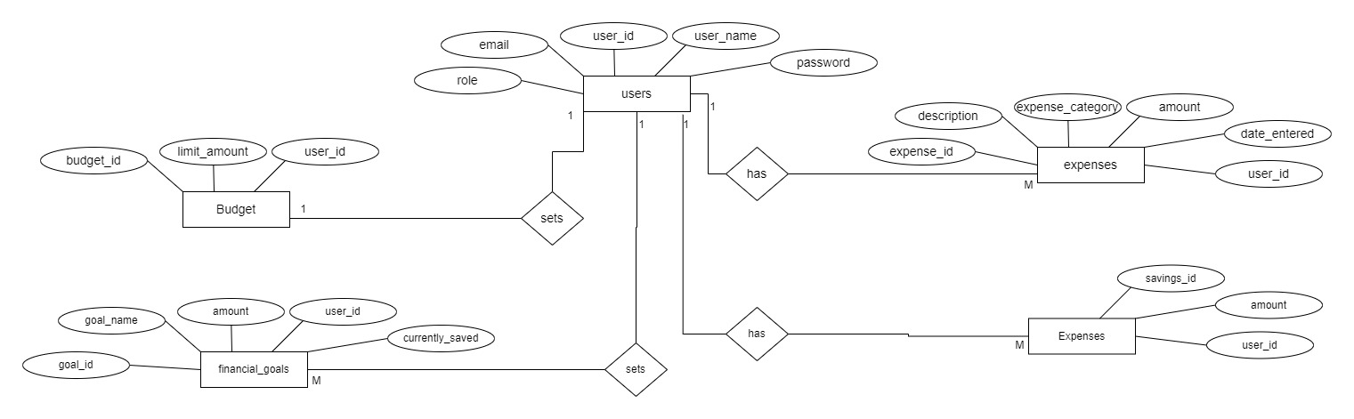

***Figure 4 E-R Diagram***

# Class Diagram

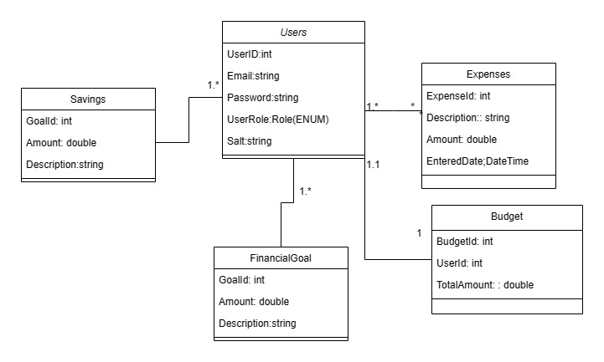

***Figure 5 Class Diagram***

# TABLE STRUCTURE:

**Tables:**

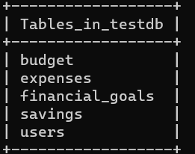.

**Users :**

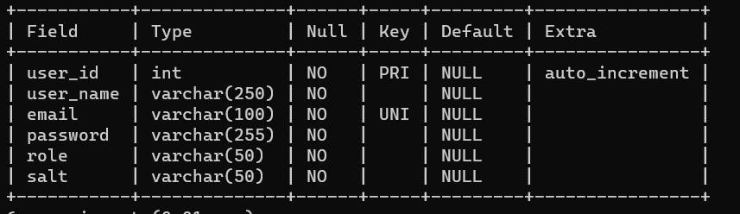

**Budget:**

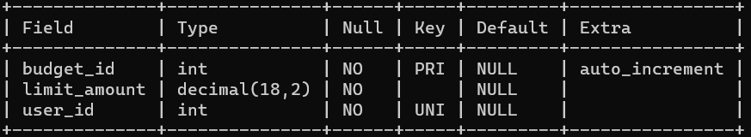

**Financial Goals:**

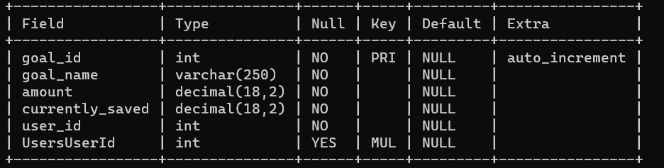

**Savings:**

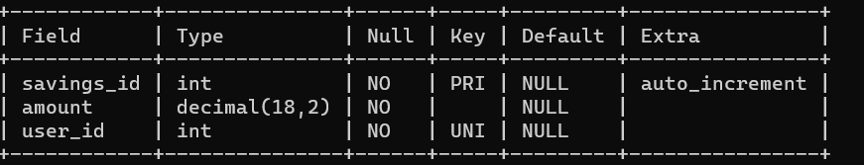

**Expenses:**

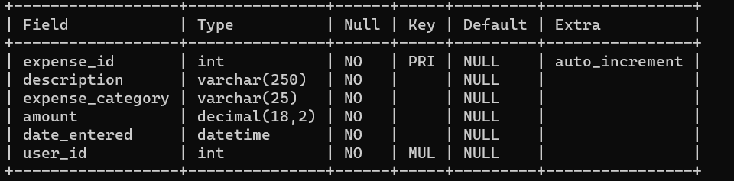

# PROJECT DIAGRAMS

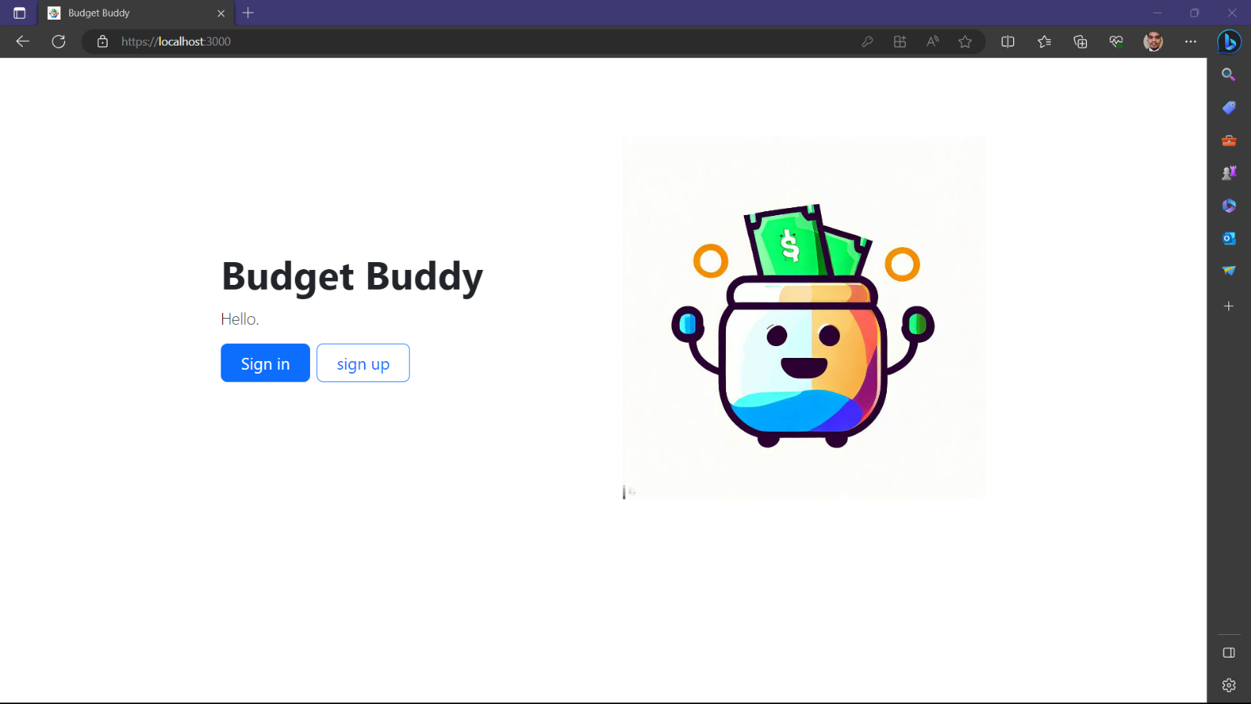

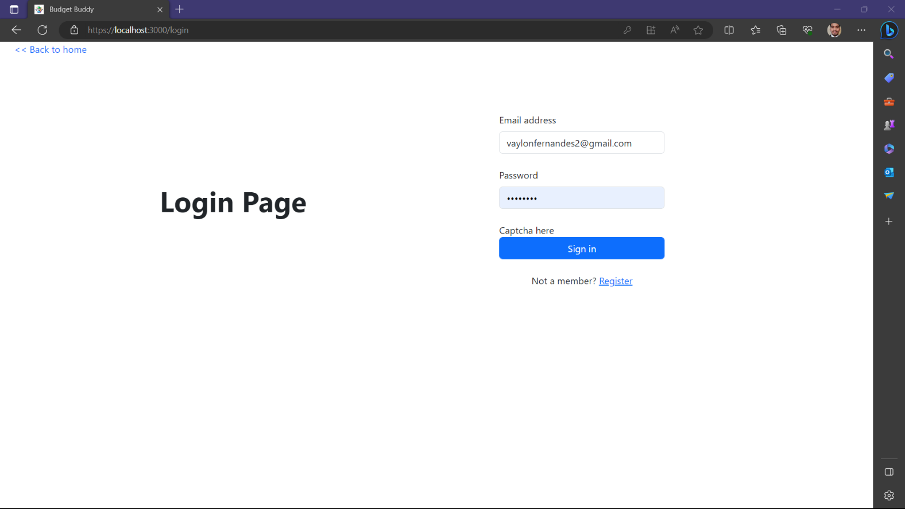

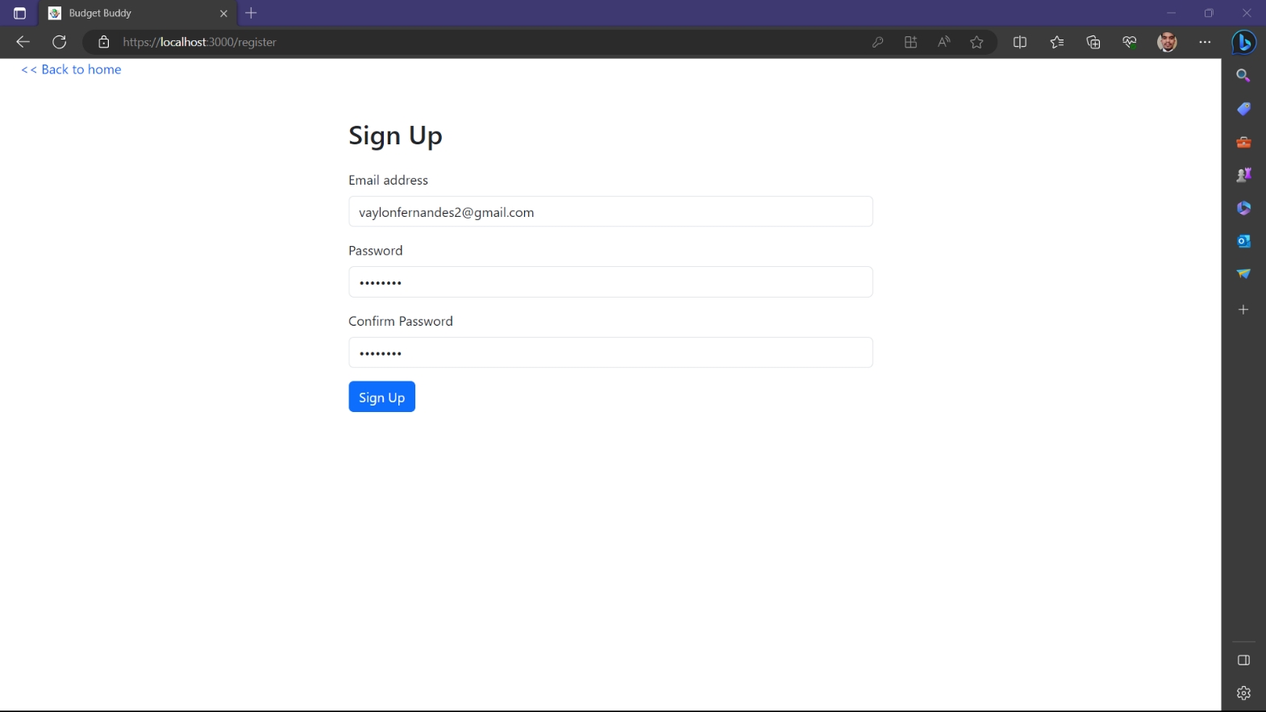

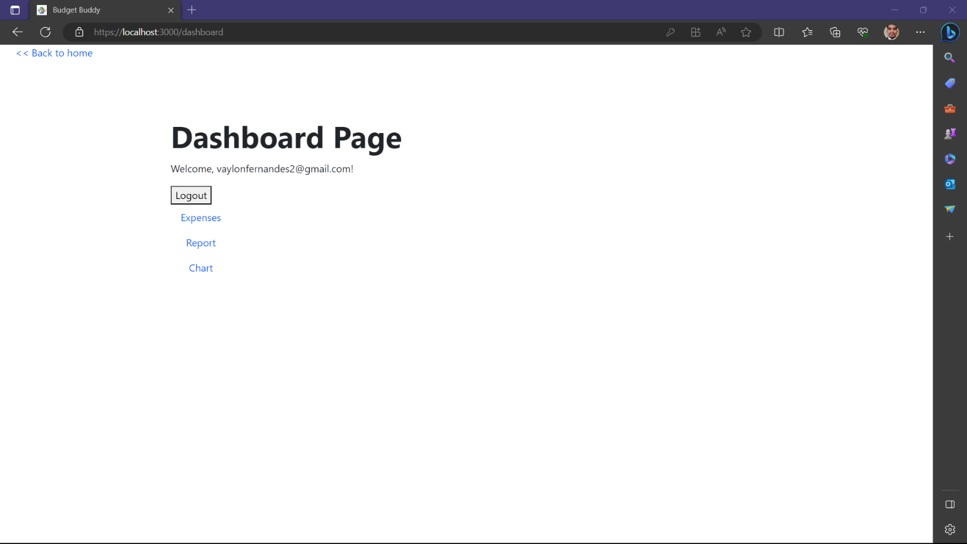

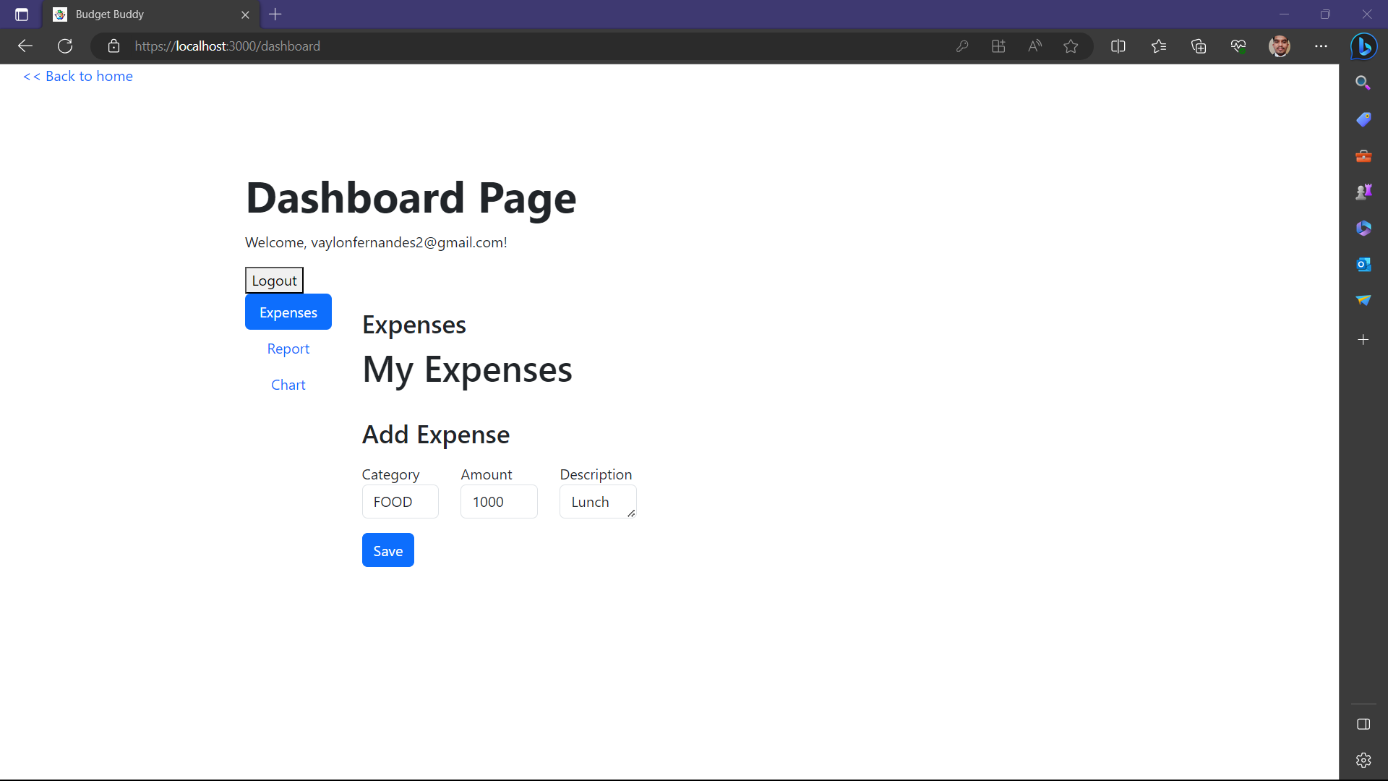

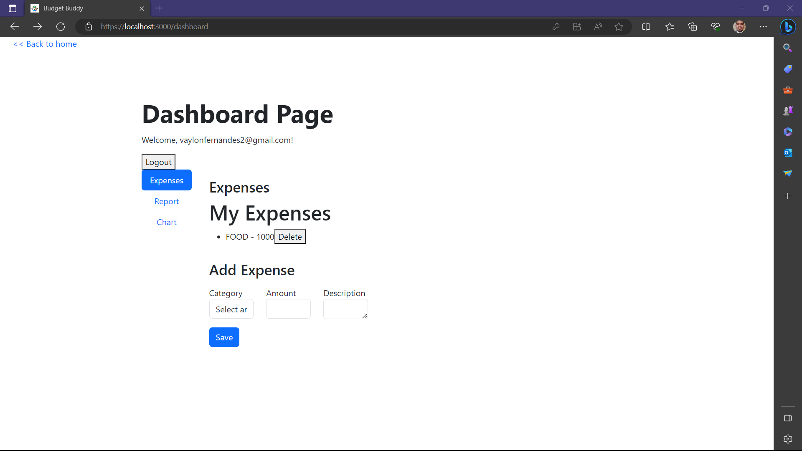

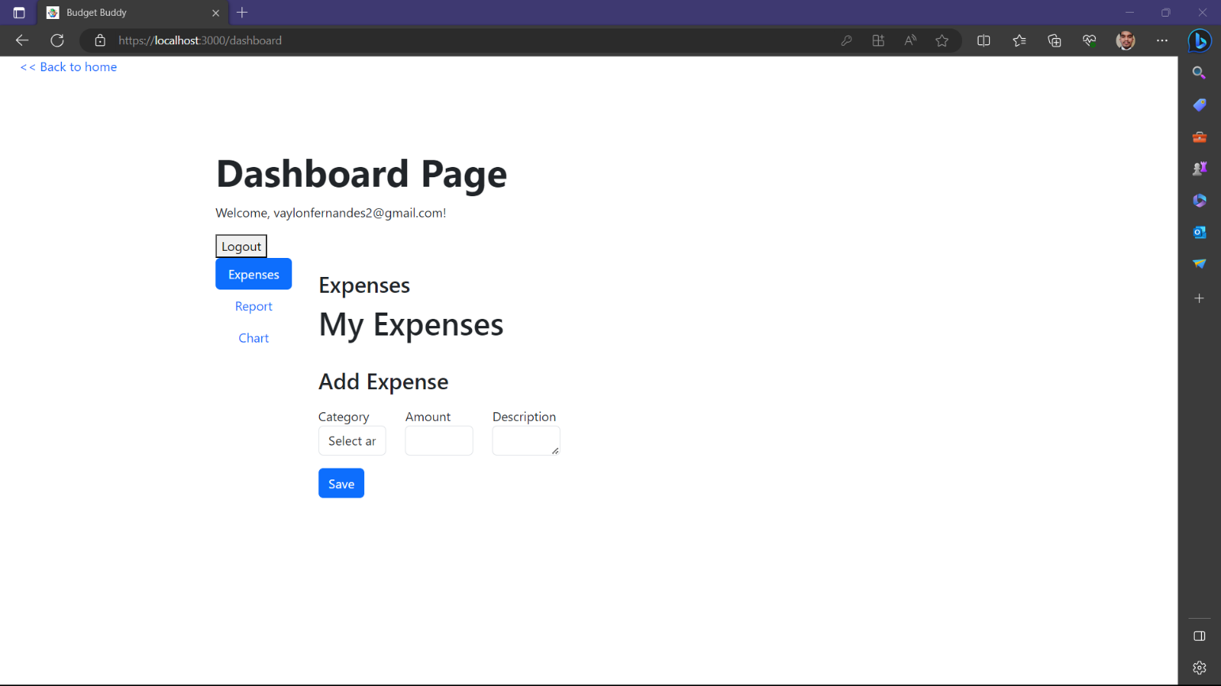

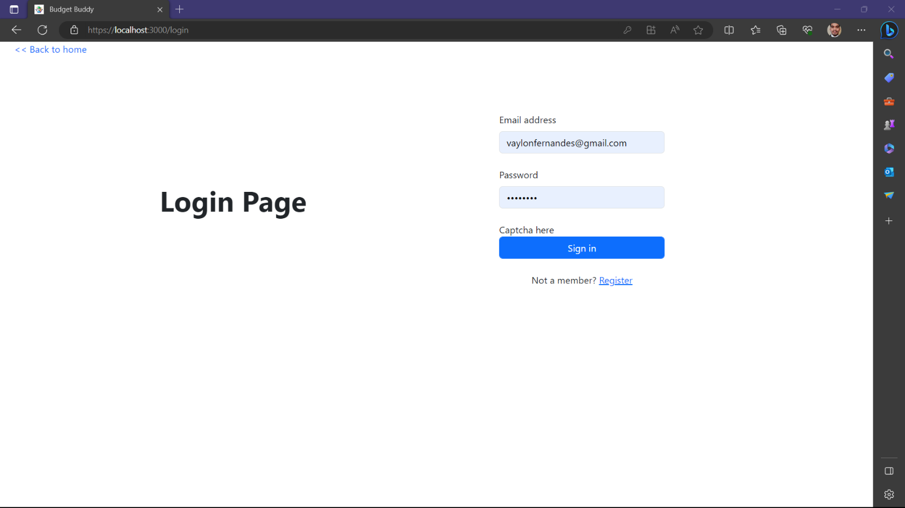

# CONCLUSION

The project entitled Budget Buddywas completed successfully.

The system has been developed with much care and free of errors and at the same time it is efficient and less time consuming. The purpose of this project was to develop a web application to manage a personal finances.

This project helped us in gaining valuable information and practical knowledge on several topics like designing web pages using React.js, usage of responsive templates, designing of android applications, and management of database using MySQL. The entire system is secured. Also, the project helped us understanding about the development phases of a project and software development life cycle. We learned how to test different features of a project. This project has given us great satisfaction in having designed an application.

There is a scope for further development in our project to a great extent. A number of features can be added to this system in future like bank integration with auto-categorization of transactions. Another feature we wished to implement was family account integration, where in users can add family members and can track expenses of all the family members. These features could have implemented unless the time did not limit us.

# REFERENCES

## ONLINE REFERENCE

* 1. <https://learn.microsoft.com/en-us/ef/core/modeling/relationships/mapping-attributes>
  2. [www.w3school.com](http://www.w3school.com)
  3. [www.stackoverflow.com](http://www.stackoverflow.com/)
  4. [www.geekforgeeks.com](http://www.geekforgeeks.com/)
  5. <https://learn.microsoft.com/en-us/ef/core/>
  6. <https://jasonwatmore.com/>
  7. <https://www.learmoreseekmore.com/>

.